Tanner 16 installation

After installation of tanner 16 .

Go to tanner eda 16 folder where you have copied

For example

E:\vlsi\all imp softwares\Tanner Tool V16\[Tanner Tools V16 0]\Tanner Tools version 16.01

Now go to patch

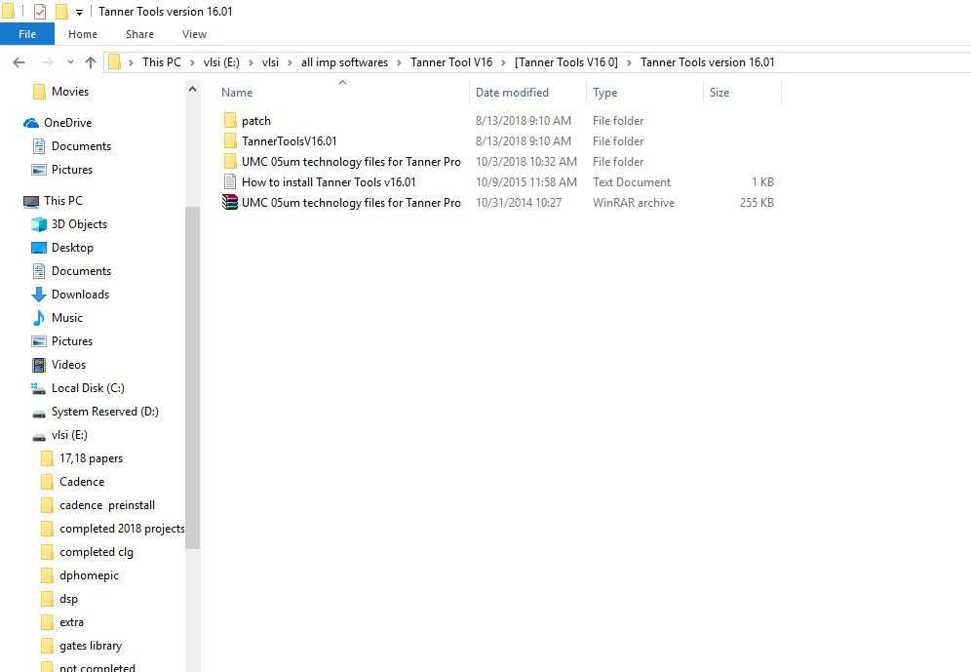

Open patch folder

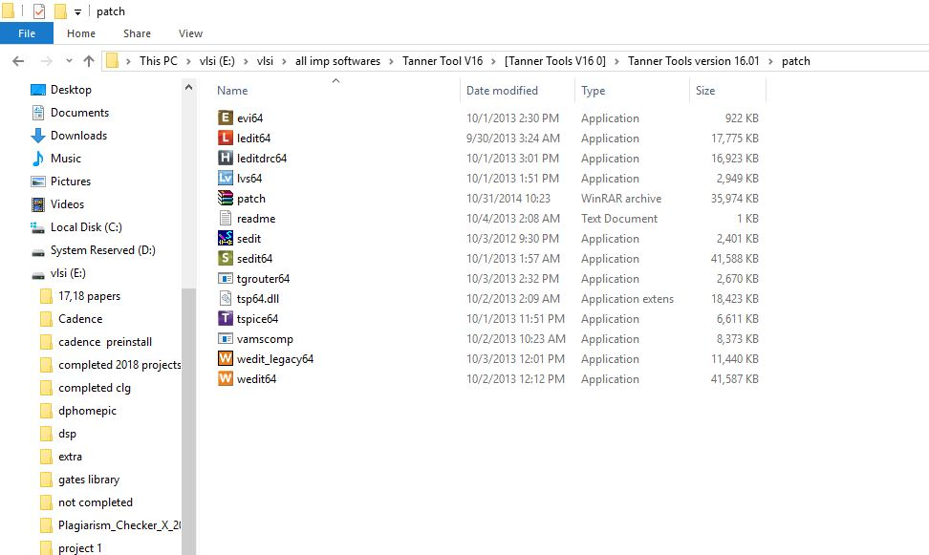

Copy the selected apps

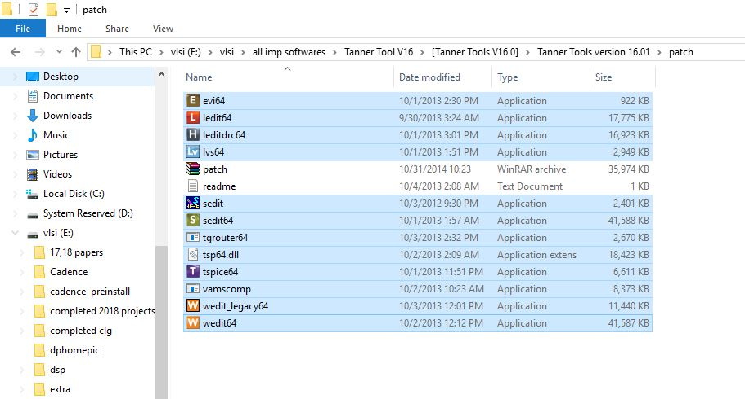

Paste it into the tanner 16 installed path ie., in c drive \program files \tanner eda \tanner 16

For example path is

C:\Program Files\Tanner EDA\Tanner Tools v16.0

Paste the above selected files here

The in the same path create a new folder and name it as

“ legacy"

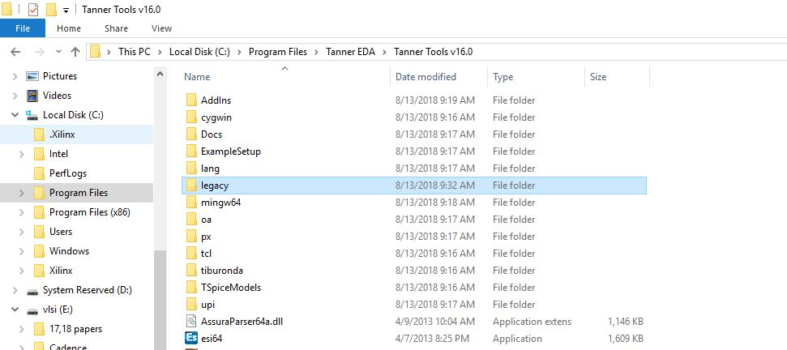

Copy the selected files from the patch folder as given below

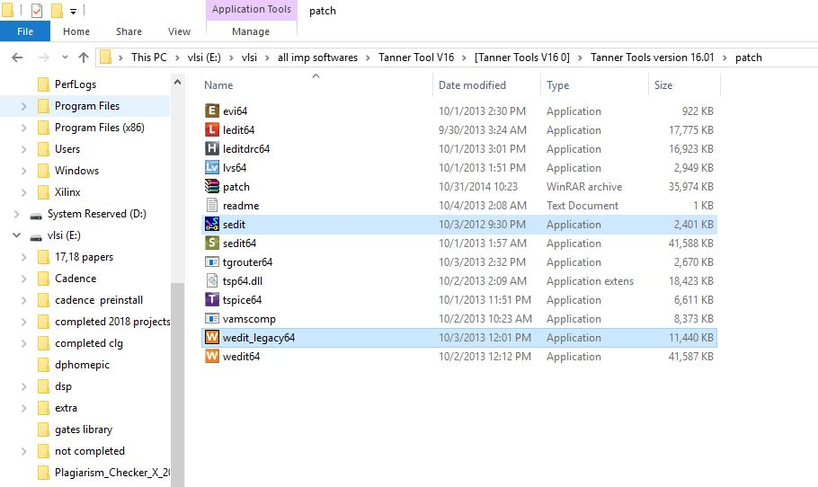

And paste this files into legacy folder which is created in c drive tanner tools 16 folder

C:\Program Files\Tanner EDA\Tanner Tools v16.0\legacy

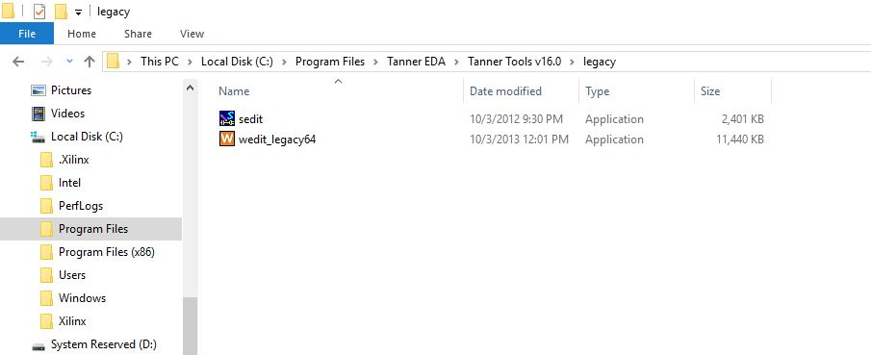

Your crack has been done successfully

Just right click on sedit 16 icon which on desktop

And select it as run as administrator

Go for the setup that’s it you have done with it .